**POWER BI DESKTOP:**

Power BI Desktop is the free version of Power BI that you can install on your local computer as a program, and acts as a companion desktop application to the full version of Power BI. It is used to consolidate your data sources, create your own reports and conduct your own analysis and test it’s capabilities. To make your reports more interactive, or analysts seeking richer detail, it's one of the best business analytics tools to use.

**POWER BI PRO:**

Power BI Pro is the full version of Power BI, complete with the ability to use Power BI for both building dashboards and reports and unlimited viewing, sharing and consumption of your created reports (and reports shared by others). It costs ₹660 Monthly per user.

Additional features of Power BI PRO:

* Ability to embed Power BI visuals into apps (PowerApps, SharePoint, Teams, etc)
* Native integration with other Microsoft solutions (Azure Data Services)
* Share datasets, dashboards and reports with other Power BI Pro users
* Can create App Workspaces and peer-to-peer sharing

**POWER BI PREMIUM:**

Power BI Premium is the most expensive tier of Power BI currently available and very distinct from the other two versions available on the market. It is basically for big data support and on premise or cloud reporting. It costs ₹3,30,190 monthly per dedicated cloud compute and storage resource with annual subscription

Features of Power BI Premium:

* Increased data capacity limits and maximum performance
* Access to one API surface
* Ability to embed Power BI visuals into apps (PowerApps, SharePoint, Teams, etc)
* Larger storage sizes for extended deployments
* Geo distribution, higher refresh rates, isolation, pin to memory, read-only replicas
* Power BI Report Server

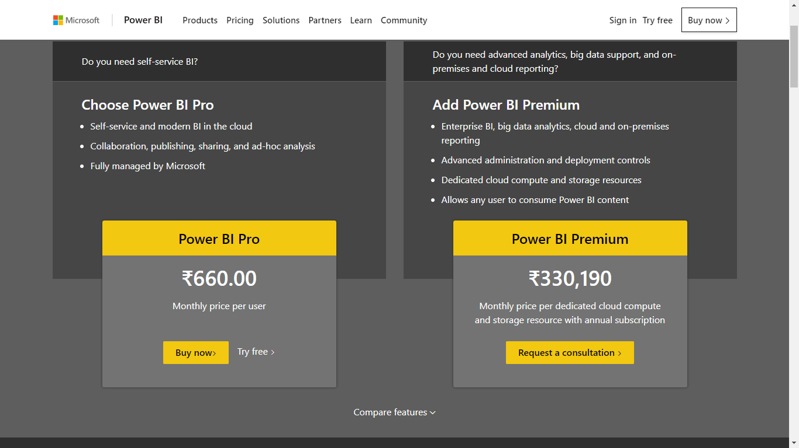

Pricing details of Power BI Pro and Premium